

SESD2213: Software Requirement Engineering

**FALL 24 PD 2**

Deadline:12 January, 2025

Read carefully

**Group Members:** Maximum 3 persons allowed in a group.

**Soft Copy Submission:** Through Portal (till 11:59 PM, 12 Jan, 2025)

**Hard Copy Submission:** In Class on 13th January 2025.

# **Late Submission:** 25% penalty for the first day, 50% for the second day, and 100% for days later.

**Evaluation:** Evaluation will be based on viva or presentation.

**Plagiarism:** There is a strict policy against plagiarism and cheating. **The penalty can be an F grade.**

**Title Page:** ATTACH THIS TITLE PAGE TO YOUR PROJECT DOCUMENT FILL INFO IN ALL BOXES BEFORE SUBMISSION.

**Total Marks: 100 (70 Documents + 30 Evaluation)**

# **Referencing/Citing:** Write in your own words to answer the following, if you use material from any book/website apart from your recommended book please provide relevant references. All work will be assumed yours otherwise.

**DECLARATION**

I SOLEMNLY DECLARE ALL THE MATERIAL PROVIDED IN PROJECT DOCUMENT HAS BEEN DONE BY ME AND/OR PROPERLY REFERENCED & ALL INFO PROVIDED IS CORRECT

*FILES WITH WRONG NAME OR EXTENSION WILL BE DELETED

(RE_A1_SEC_SRNO_4digitROLLNO_FIRSTNAME.DOC/PDF) eg A1_B_08_2346_HARIS.pdf

**SUBMISSION DATE SUBMISSION TIME**

**Project Name**

**SIGNATURE NAME**

**Reg# Section**

**TITLE OF FILE SUBMITTED IN SOFTCOPY**

**Course Outcomes**

|  |  |  |  |
| --- | --- | --- | --- |
| **CLO #** | **Course Learning Outcomes (CLO)** | **Taxonomy Level** | **Mapping to PLO** |
| CLO 3 | **Create** UML-based system modeling language artifacts for requirements analysis and requirements specification | C5 | 4 |

**CLOs Testing (OBE Evaluation)**

|  |  |  |  |  |  |  |  |
| --- | --- | --- | --- | --- | --- | --- | --- |
| **CLO** | **Tested** | **Keywords** | **Domain** | **Questions** | **Marks** | **Obtained Marks** | **Total** |
| 2 | No |  |  |  |  |  |  |
| 3 | Yes | Create, Draw, Show | C5 | Q1 | 10 |  |  |
|  |  |  |  | Q2 | 45 |  |  |
|  |  |  |  | Q3 | 10 |  |  |
| 4 | No | - | A3 |  |  |  |  |

1. Identify 12 functional requirements of your project. The requirements should be written in statements as explained in examples of slide sets. **[10]**
2. Prioritize the requirements identified in Question 1 using the given requirement prioritization techniques. Provide detailed calculations and clear step-by-step explanations. Missing steps or unclear reasoning will result in a mark deduction.
   1. 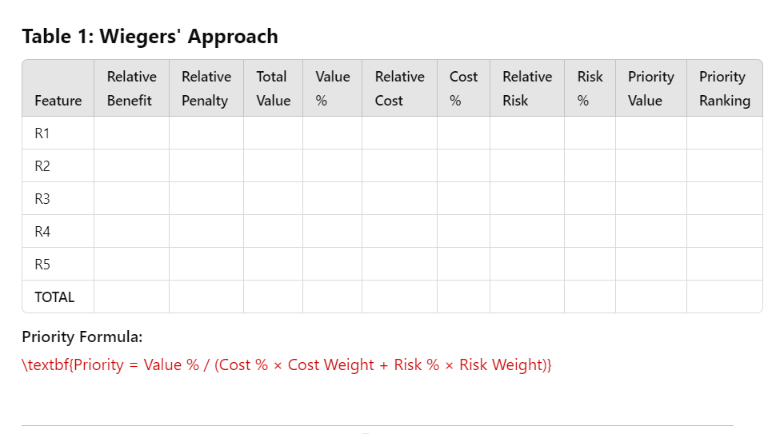**Weiger’s Prioritization [15]**
   2. 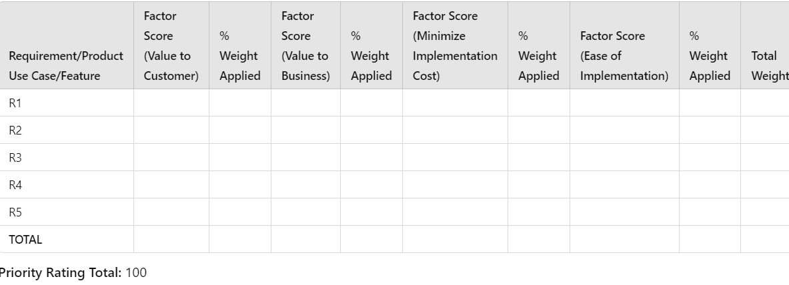**Volere Prioritization [15]**
   3. **Analytic Hierarchy Process [15]**

**Consider the following table:**

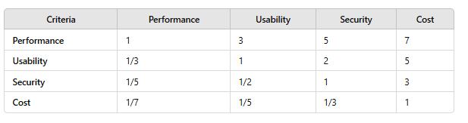

1. For each of the above-applied techniques, find out the priority of each feature and arrange the features according to priority in descending order. **[10]**